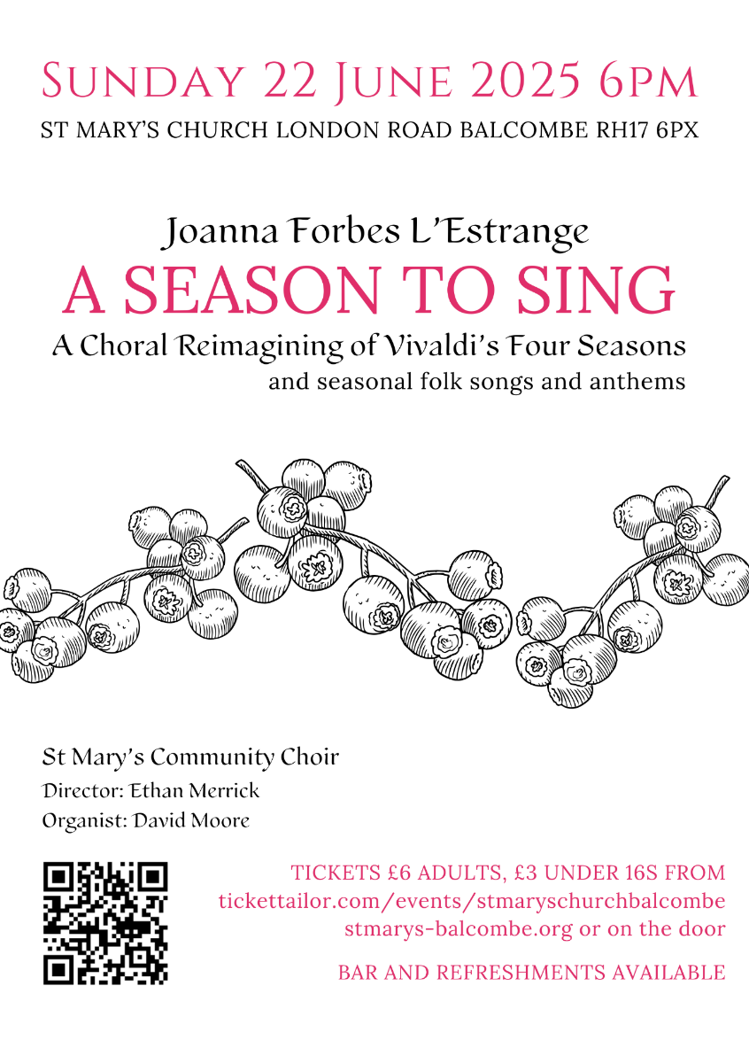

**We are always looking for volunteers to help our services run smoothly. If you would like to help with reading, welcoming, serving, or acting as a duty warden, please contact ali on services@stmarys-balcombe.org**

The next Parish Prayer Meeting will be on Tuesday, 1st July at 7.45pm in the Parish Room. All welcome.

**COFFEE + In Church**

**Every Monday morning during term time in church, do join us for free tea, coffee and pastries between 9.30 and 11am. Everyone welcome.**

**St Mary’s Church, Balcombe**

**Grapevine**

**15th June 2025**

**Trinity Sunday**

**Weekly Diary**

**TODAY 8am Holy Communion (BCP)**

**9.30am Parish Eucharist with**

**Fr David**

**3-5pm Concert Rehearsal**

**Sunday 8am Holy Communion (BCP)**

**Next 9.30am Parish Eucharist with**

**Fr John Twisleton**

**6pm A Season to Sing Concert**

**PRAYERS THIS WEEK:**

**All those who live in**:

High Street, Jobes and London Road.

**All those who are sick, especially** Derek Hall, David Vickerstaff, Beryl and John Longley, Pam Taylor, Annie Greig, Adam, Fiona Smith, Annie, Sheila King, Carole Tingey, Desmond and Jenny Longfield, Zina, Mishi and Brenda.

**The departed, our own departed loved ones and** **those whose anniversaries occur during the week :** Manville Fenn, Flora Botting, Winifred Chatten, Mary Stapleton and Ethel Fairweather.

**Celebrating 950 Years**

**2025 marks the 950th anniversary of the formation of the Diocese of Chichester and Chichester Cathedral.**

In 1075 the decision was made to move the seat of the Bishop from Selsey to the more populous Roman settlement of Chichester. This was followed by the construction of the Cathedral, a sacred place of worship and Mother Church to the Diocese - a flourishing Christian community within the boundaries of East and West Sussex.

To celebrate 950 years of religious, cultural and civic life across the City, District and Counties, the Diocese and Cathedral have curated a diverse programme of events taking place in 2025. To find out more about our plans, go to [https://www.chichestercathedral.org.uk/ Chichester950](https://www.chichestercathedral.org.uk/%20Chichester950)